# **VMM Brand Guidelines**

<https://www.vishalmegamart.com/>

## **About Vishal Mega Mart**

Vishal Mega Mart (VMM) is India’s leading Fashion led hypermarket with 550+ stores spread across India. Vishal Mega Mart’s mission is to make aspirations affordable for all its customers by providing shoppers with a wide range of Latest Fashion, General Merchandise and Grocery needs. Vishal’s customers love its unique combination of great quality and amazing prices.

## **Logo**



## **Imagery on website**

Images/videos/gifs and other media that can be included in messages can follow a certain style that can be interpreted from the following images that are taken from the Vishal Mega Mart’s official website.

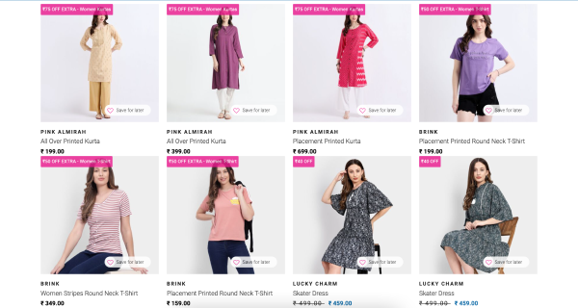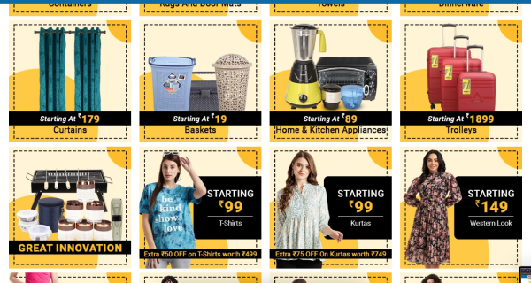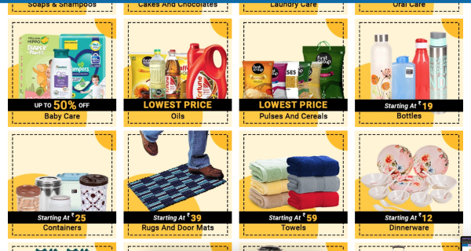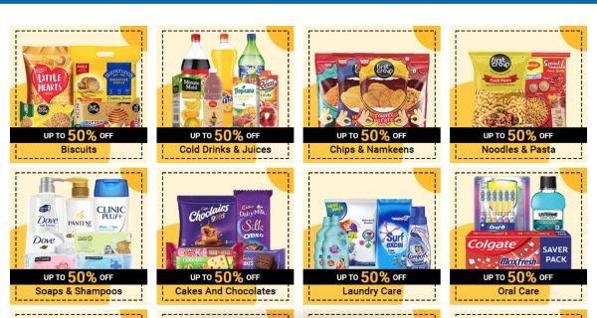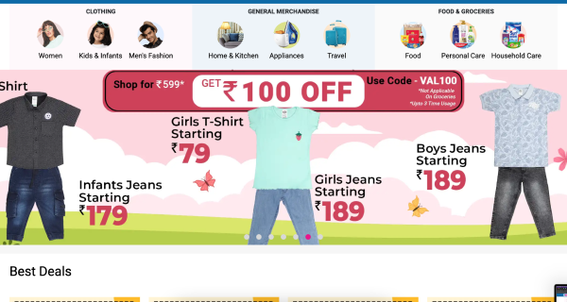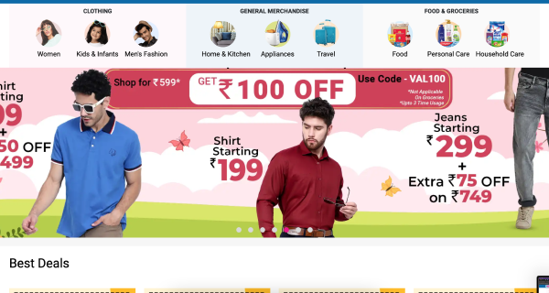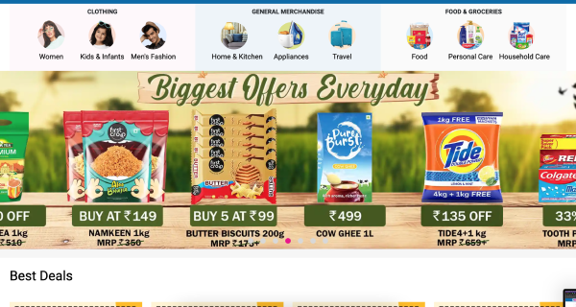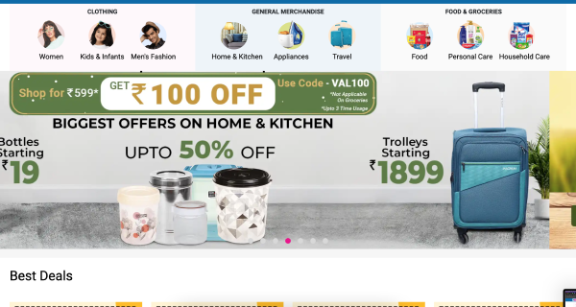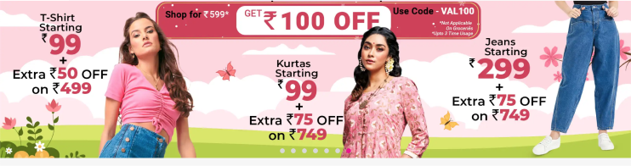

## **VMM’s voice and tone for communication**

Vishal Mega Mart's communication should embody a friendly and approachable voice, coupled with a positive and engaging tone. It should be confident, informative, and empathetic, while also reflecting the brand's dynamism and commitment to transparency and inclusivity. This communication style aims to build trust, connect with customers, and deliver value by providing clear, helpful, and engaging content that resonates with the target audience. VMM’s voice and tone can also be fine tuned by adhering to it’s brand personality, mission statement and values.

### **VMM’s brand personality**

Vishal Mega Mart's brand personality is likely characterized by traits such as:

1. **Accessible:** The brand is approachable and caters to a wide range of customers, making quality products available to all segments of society.

2. **Trustworthy:** Vishal Mega Mart is perceived as a reliable and trustworthy retailer, known for its transparent pricing and honest business practices.

3. **Friendly:** The brand exudes warmth and friendliness, creating a welcoming atmosphere for shoppers.

4. **Dynamic:** With its focus on innovation and adaptability, Vishal Mega Mart is seen as a dynamic and forward-thinking brand that evolves with the changing market trends.

5. **Value-driven:** Emphasizing affordability and value for money, the brand is associated with smart shopping choices and budget-friendly options.

In essence, Vishal Mega Mart's values, mission statement, and brand personality collectively reflect its commitment to delivering quality products, exceptional service, and value to its customers while upholding ethical standards and fostering a positive organizational culture.

### **VMM’s mission statement**

Vishal Mega Mart's mission is likely to revolve around providing quality products at competitive prices while delivering an exceptional shopping experience to its customers. It may emphasize the company's commitment to offering a diverse selection of goods, maintaining affordability, and continuously improving its services to meet the evolving needs of its customers.

### **VMM’s values**

1. **Customer-Centricity:** Vishal Mega Mart places a strong emphasis on understanding and fulfilling the needs of its customers. This is reflected in its efforts to offer a wide range of products at affordable prices.

2. **Integrity:** Upholding ethical standards in all aspects of its operations is a core value for Vishal Mega Mart. This includes transparent pricing, fair business practices, and honesty in dealings with customers and stakeholders.

3. **Innovation:** The company strives to innovate continuously, both in terms of its product offerings and its operational processes. This commitment to innovation helps Vishal Mega Mart stay relevant in a competitive market and deliver value to its customers.

4. **Teamwork:** Collaboration and teamwork are valued within the organization. Vishal Mega Mart recognizes that its employees are crucial to its success and fosters a supportive and inclusive work environment.

## **Target audience**

Vishal Mega Mart's target audience typically includes a broad spectrum of consumers across various demographics, primarily focusing on:

1. **Value-Conscious Shoppers:** Individuals or families seeking affordable and budget-friendly shopping options without compromising on quality.

2. **Middle to Lower-Income Groups:** Those looking for everyday essentials, clothing, household items, and groceries at competitive prices.

3. **Urban and Semi-Urban Dwellers:** Residents of urban and semi-urban areas where Vishal Mega Mart outlets are typically located, making it convenient for them to access the stores.

4. **Family-Oriented Customers:** Families looking to fulfill their diverse shopping needs under one roof, including clothing, groceries, home essentials, and more.

5. **Young Adults and Millennials:** Budget-conscious young adults and millennials who appreciate the variety of products offered at Vishal Mega Mart and seek value for their money.

6. **Rural Consumers:** In some cases, Vishal Mega Mart may also cater to consumers in rural areas where it provides access to a wide range of products at affordable prices, serving as a one-stop destination for shopping needs.

Overall, Vishal Mega Mart's target audience encompasses a diverse range of consumers who prioritize affordability, convenience, and value when making their purchasing decisions.

## **Communication channels guidelines**

All content generated for VMM should maintain consistency across all channels to reinforce brand identity and build trust with the audience. Certain standards and guidelines should be followed for each channel while messages still convey the same values, tone and style regardless of the channel.

### 

### **SMS:**

1. **Character length limit:** 200 characters

2. **Content generation guidelines:** VMM’s content for SMS should not contain any emojis. Offer value with concise, personalized content, including clear calls-to-action. Provide easy opt-out options, and adhere to regulations. Continuously test and optimize message content for effectiveness while handling data securely.

### **Email:**

1. **Subject line character length limit:** 30-50 characters

2. **Email body character length limit:** 600-800 characters

3. **Content generation guidelines:** When generating content for emails, prioritize, clarity, and relevance. Use recognizable sender information, and craft compelling subject lines. Personalize content and ensure emails are concise and mobile-friendly. Include clear CTAs prompting desired actions, and segment your audience for targeted messaging. Test different elements for optimization and adhere to data protection regulations, offering unsubscribe options. Use visual elements like emojis that will enhance the appeal of templates and convey emotions effectively. Include optimized image/video/gif and other media that is the most relevant to the content and that might increase user engagement.

### **Push notification:**

1. **Character length limit:** 40-120 characters

2. **Content generation guidelines:** When generating content for Push notifications, craft effective content, prioritize relevance, clarity, and personalization. Include clear CTAs for action. Communicate value clearly. Test different strategies for optimization and ensure compliance with regulations like GDPR. Use visual elements like emojis that will enhance the appeal of templates and convey emotions effectively. Additionally, personalize notifications based on user behavior or location for increased engagement. Incorporating visually appealing elements and offering opt-out options further enhance user experience and brand reputation. Include an optimized image that is the most relevant to the content and that might increase user engagement.

### **WhatsApp:**

1. **Character length limit:** 40-120 characters

2. **Content generation guidelines:** When generating content for WhatsApp communication, follow specific guidelines to ensure effectiveness. It's crucial to understand and adhere to WhatsApp's guidelines for template messages. These guidelines govern the types of messages that can be sent through WhatsApp's business API and help maintain a positive user experience.

Content for WhatsApp template messages should prioritize clarity, conciseness, and relevance. Ensure compliance with guidelines and character limits. Personalization is key to engaging recipients, so templates should be tailored to the recipient's context, such as their name or recent interactions.Including a clear call-to-action (CTA) prompts recipients to take the desired action, such as replying or clicking a link. Based on the context, include phone number and website link CTAs or some quick reply buttons. Use visual elements like emojis that will enhance the appeal of templates and convey emotions effectively. Compliance with WhatsApp's policies and regulations is paramount to maintain the integrity of the communication channel and avoid spammy or promotional content.

## 

## **Compliance and legal considerations**

Ensure all the message content adhere to legal requirements and industry regulations, especially when dealing with target markets. Avoid any content that could potentially harm the brand’s reputation or violate laws.